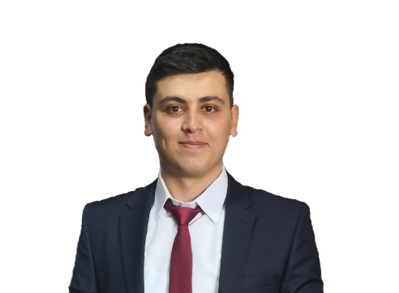Zafer UZUN

30 Agustos Neighborhood 2115 Street 6/6

Etimesgut/ANKARA

05379151803

[uznzafer@gmail.com](mailto:uznzafer@gmail.com)

[github.com/zaferuzun](https://github.com/zaferuzun)

PERSONAL INFORMATION

Date of Birth 30.08.1997

Marital Status Single

Military Service Reprieve (05.11.2022)

Driving License Available (Class B)

ABSTRACT

I have just graduated from Ataturk University, Department of Computer Engineering. Iaim to combine the theoretical training infrastructure I have reduced with the practical information that I will gain in the relevant position. I want to gain experience improving myself and expanding my vision.

JOB EXPERIENCE

**2020 aracimtakip.com**  **(demo)**

* ASP.Net, MVC,Javascript, Ajax,HTML,CSS, jQuery
* A platform for companies and individuals to follow parameters such as taxes and inspections of their vehicles

**02.09.2019-25.10.2019 Meyer Group INTERNSHIP**

* Research and Studies on C# Programming
* Research and Studies on ASP.Net
* Vehicle Tracking System Development
* Reference Barış KES
* Reference Timuçin KORKMAZ

**30.07.2018-03.09.2018 Havelsan Technology Radar Inc. INTERNSHIP**

* FPGA and ASIC Research
* Research on Microcontrollers and Microprocessors
* LPC 1769 Developer Card Research
* LPC 1769 Developer Card Studies

**2018 diyahukuk.com**  (site is currently active.)

* Installation and Management of the Site
* Social Media Accounts Management
* Youtube Account Management
* Reference Alim YABAN

**2017 dincoz-yaban-altinyuzuk.av.tr**  (site is not currently active.)

* Installation and Management of the Site
* Social Media Accounts Management
* Reference Alim YABAN

PROJECT EXPERIENCE

**2019- Javascript and Nodejs Applications**

* Epoch time account with Javascript, HTML, CSS, Nodejs, Nodejs request-response, Nodejs Mongodb, Nodejs redis

**2018-2019Parallel Programming**

* C++, Using ile Mpi functionswith ShellCommands, howrak photo medianing

**Arduino Projects**

* Line-Tracking Robot
* Bluetooth Control Robot
* Sumo Robot
* Obstacle-Recognizing Robot

**Amazon Rekognition Technology**

* Making A Turkish Tutorial
* Expanding the AI Source in the Country
* AWS and Rekognition Services Use
* Project Realization on DetectFaces, ModeratingLabels, DetectLabels Topics with Python
* **Media:** JetBrains PyCharm, Amazon

**2017-2018Website**

* Construction of www.worldart.com Art Site with HTML/CSS/JavaScript

**Cinema Automation**

* Desktop Cinema Automation with JavaSwing, JDBC, MySQL, Wampserver

**Android Project**

* English with Android, MySQL , Wampserver,PHP – English Android Game

**2016-2017 Arduino Projects**

* Development of Various Projects with Arduino, C, C++, Assembly and Arduino development card

**teknokafe.com**

* Android Studio usage and presentations of small projects
* Technology News Presentations

**2015-2016Bank Project**

* Bank Project Using OOP with C++

**Console Games**

* Adam Asmaca with C, Finding Words

**Python Studies**

* Development of Various Projects with Python

EDUCATION INFORMATION

2015-2019Ataturk University

Undergraduate, Department of Computer Engineering

SEMINARS AND COURSES

Career Tips from 2017Kariyer.Net Erzurum

2018Erzurum TIM-TEB Enterprise House Wake Up program (26-29 February)

2019Academic Information 2019 Conference (Modern Web and PHP Education)

SOFTWARE INFORMATION

* Java SE Intermediate
* JavaScript Intermediate
* HTML,CSS Intermediate
* C,C++ Intermediate
* MySQL Intermediate
* Arduino Intermediate
* Android Intermediate
* Python Intermediate
* R programming Basic Level
* Shell programming Intermediate
* Parallel programming Intermediate
* PHP Base linelevel
* Ionic (Hybrid Technology) Intermediate
* Nodejs Base Level
* C# Intermediate
* Asp.Net Intermediate

FOREIGN LANGUAGE

* English
  + Listening B1
  + Writing B1
  + Reading B1
  + Speaking B1

PARTICIPATING CLUBS

* **Atugem Club:** Giving Software-Robotics trainings through Middle School, High School and University Arduino in Atugem Erzurum Province is the clup established in order to spread this culture in our country. I took 2015 Fall semester trainings and carried out projects in trainings and started trainings in secondary schools in Erzurum Province in the spring semester of 2015.

**Mission at the Club:** Instructor, Technical Team

References

|  |  |  |  |
| --- | --- | --- | --- |
| Barış KES | baris.kes@meyer.com.tr | +90 533 681 97 85 | Software and R&D Team Leader |
| Timuçin KORKMAZ | timucinkorkmaz33@gmail.com | +90 542 537 03 54 | Software Development |
| Mehmet ZORKOL | mehmet@btsector.com | +90 507 555 69 17 | Software Manager |
| Alim YABAN | [avalimyaban@gmail.com](mailto:avalimyaban@gmail.com) | +90 530 040 65 84 | Lawyer |